
maryam jahangir 241949
FSWD LAB 6


Task 1
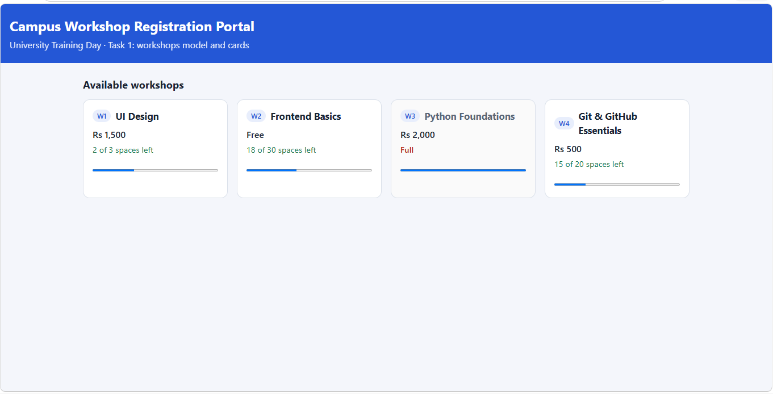
Task 2
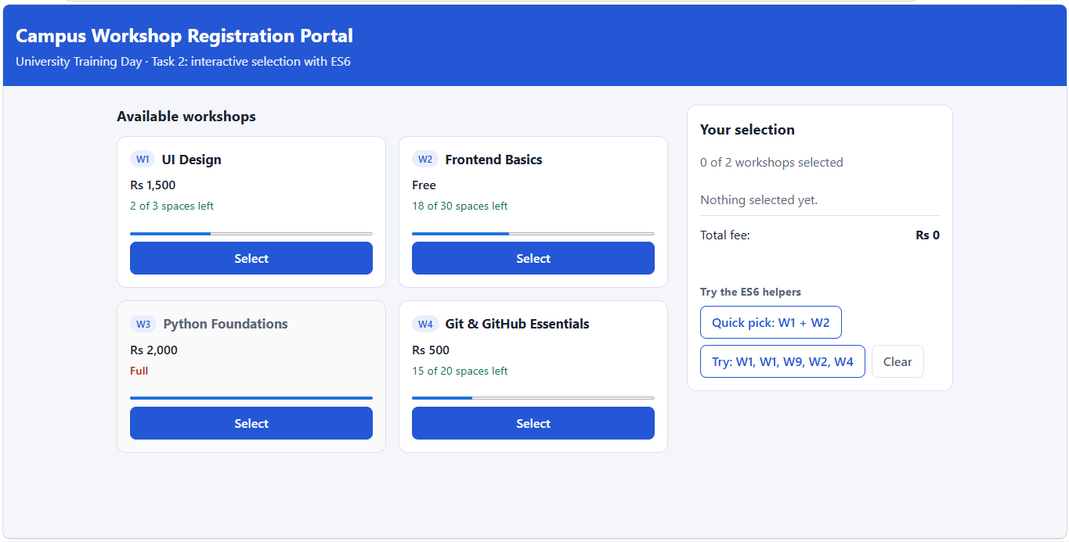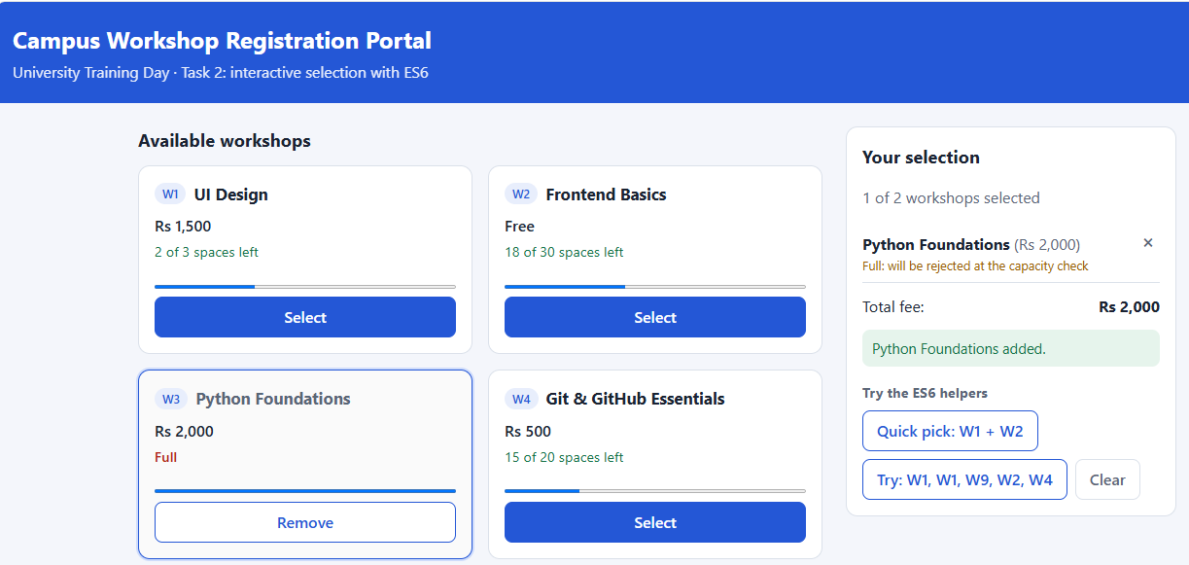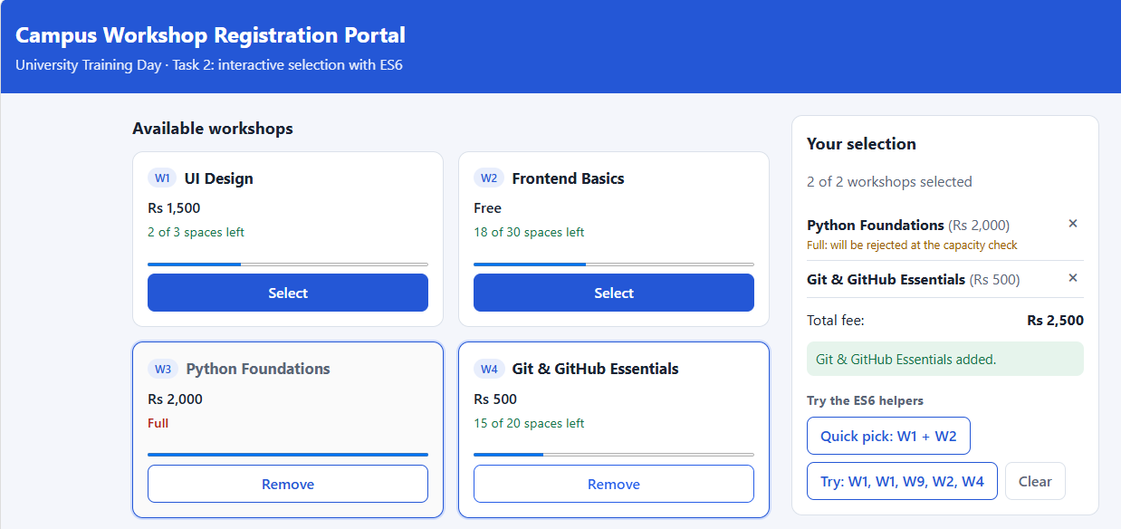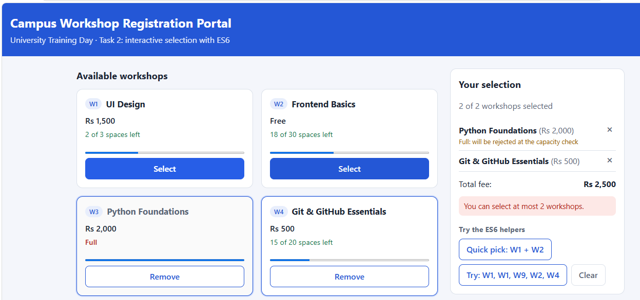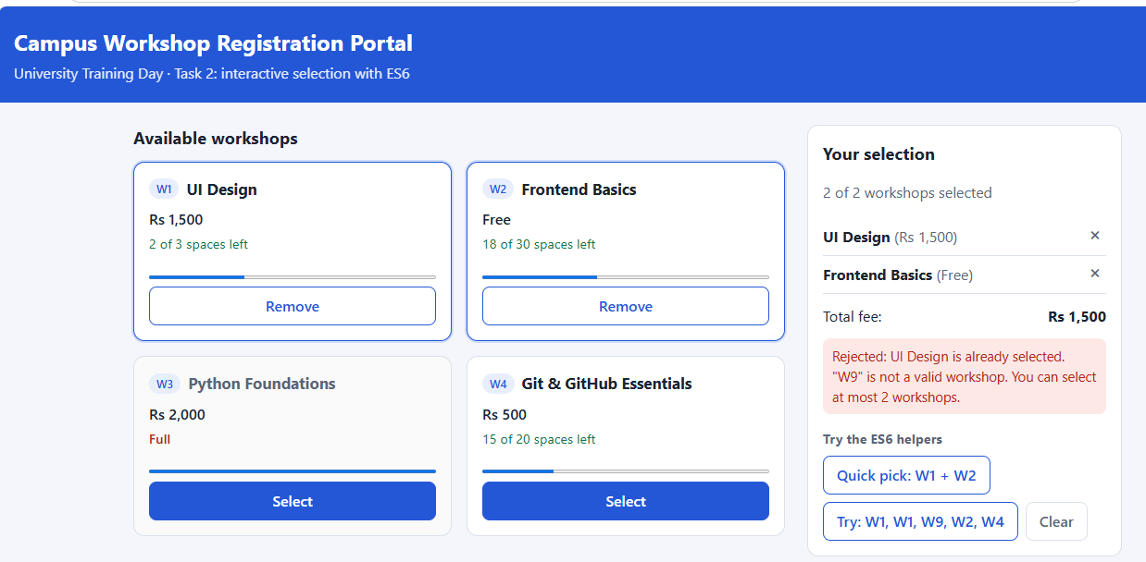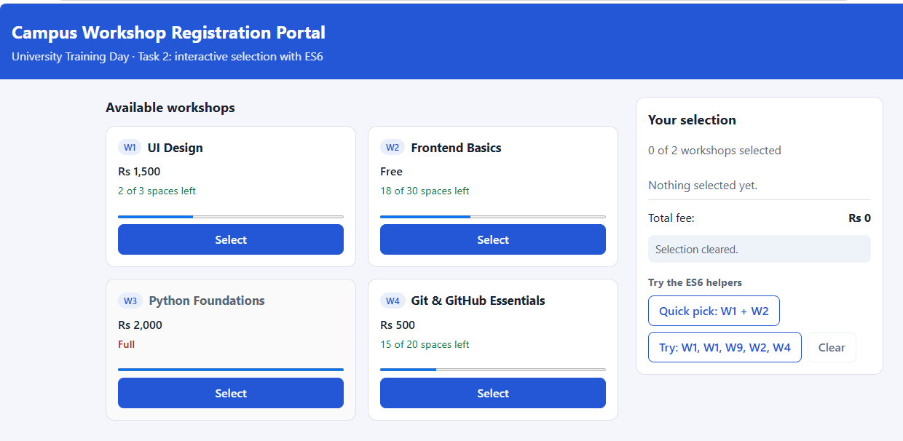
Task 3
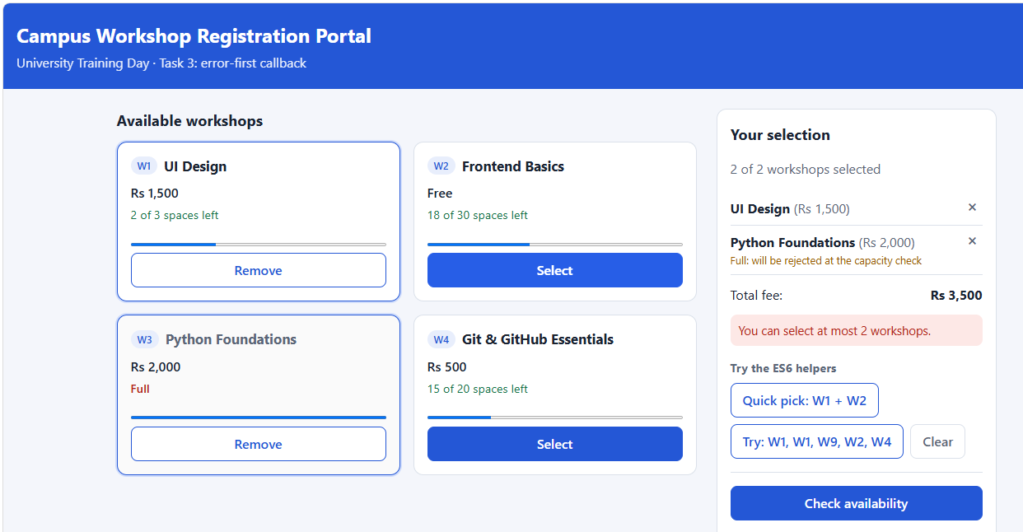
Task 4
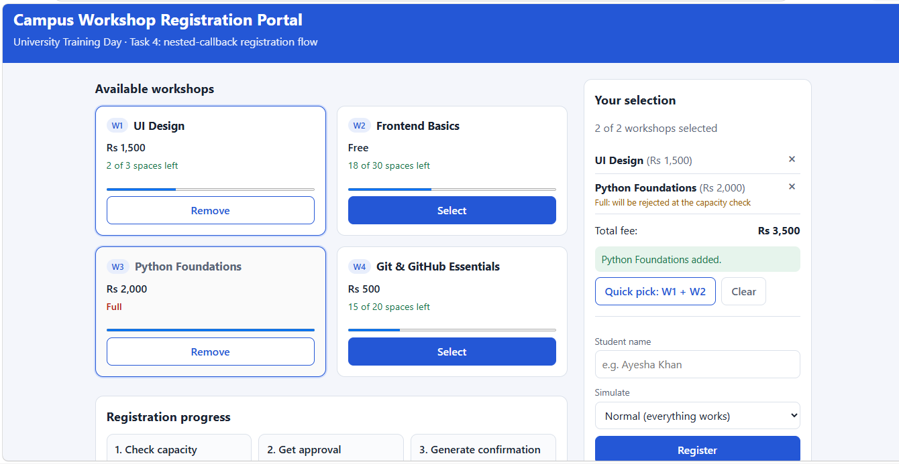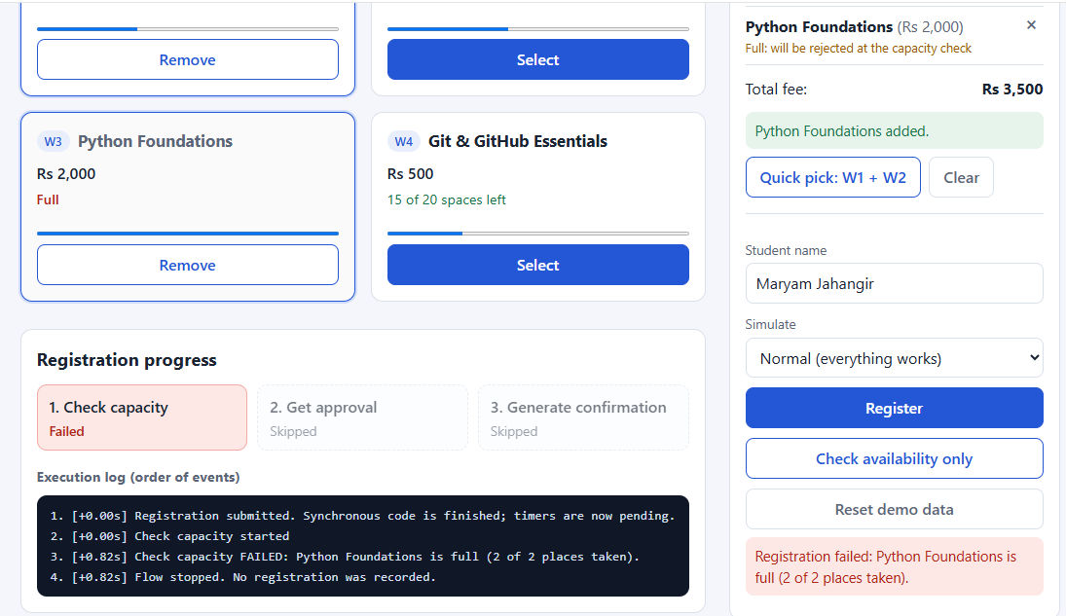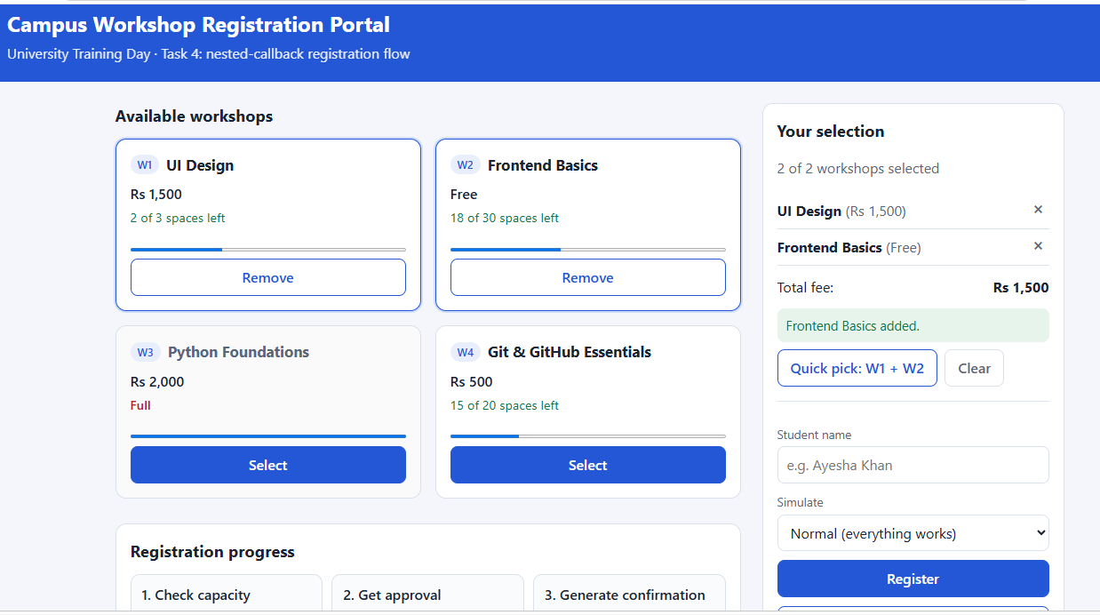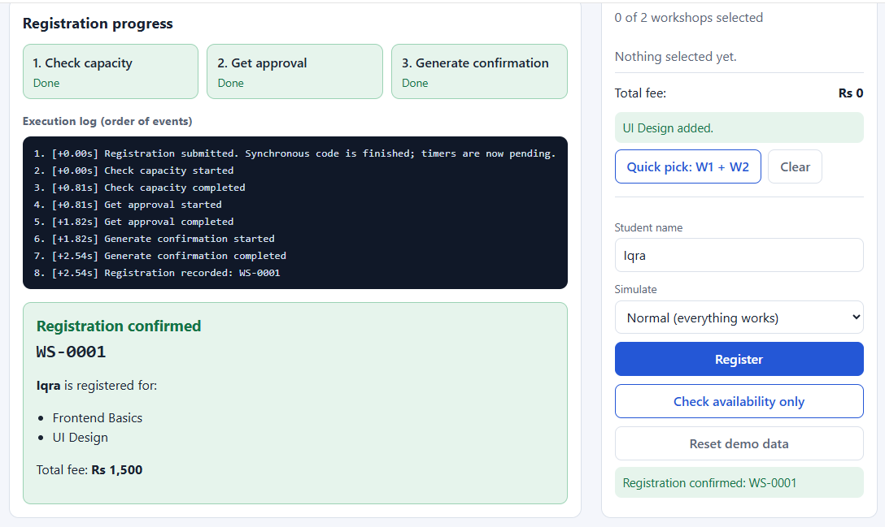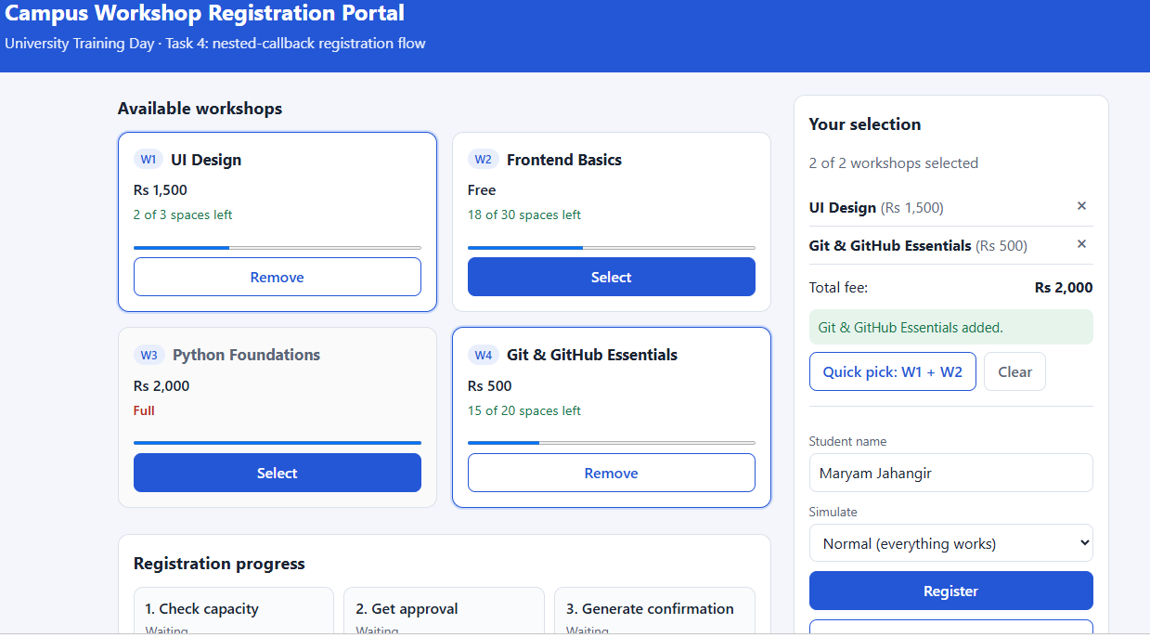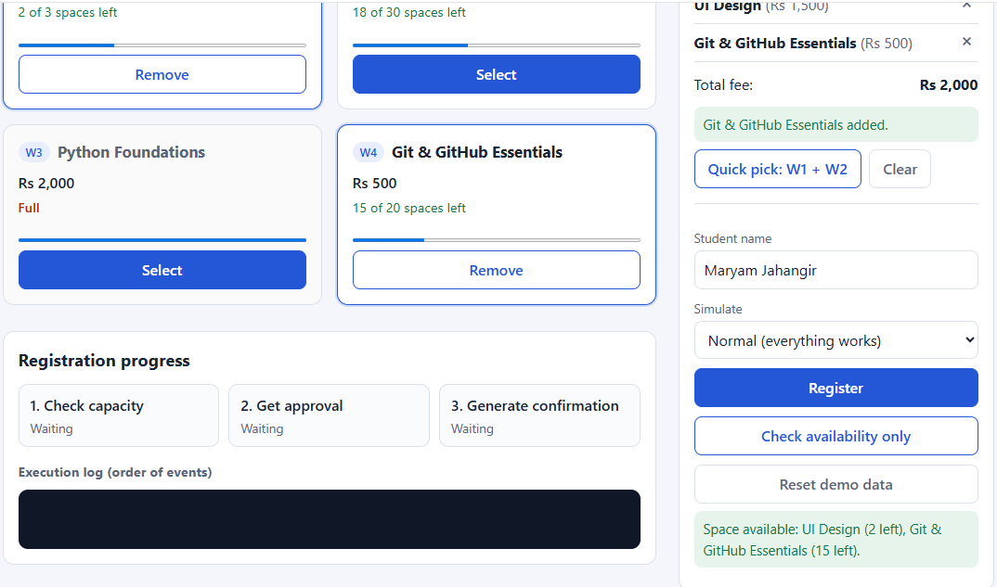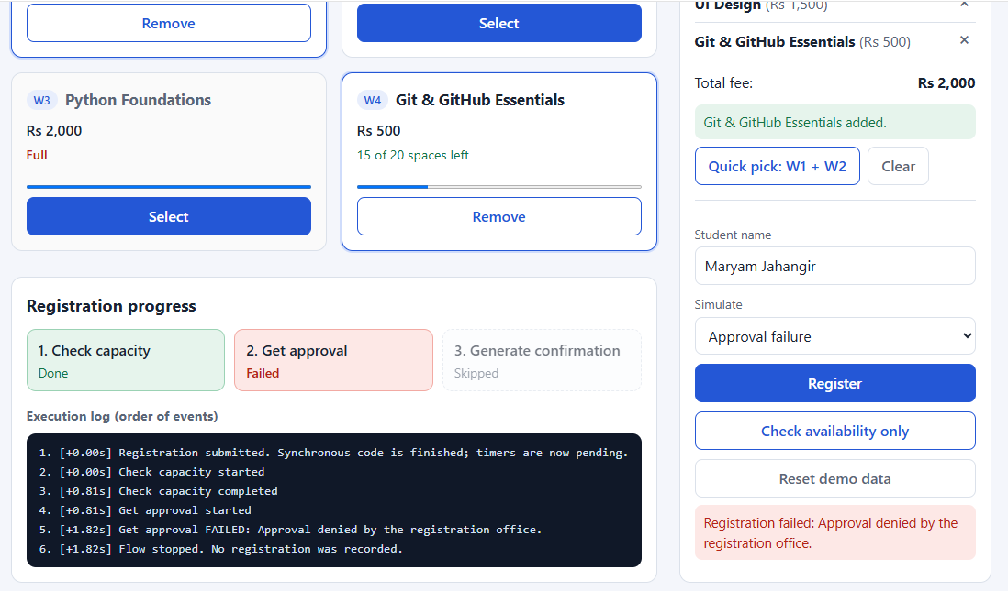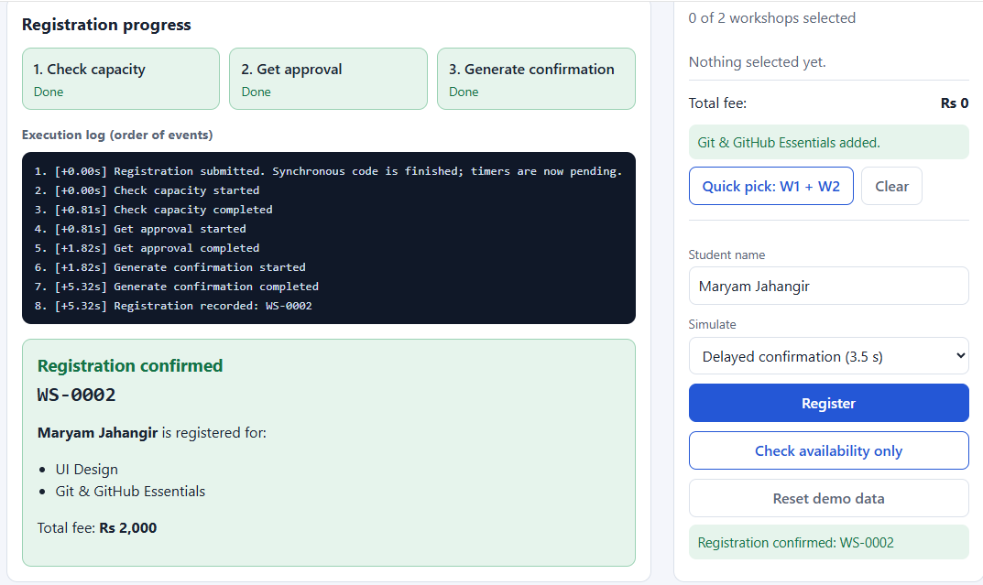
Task 5
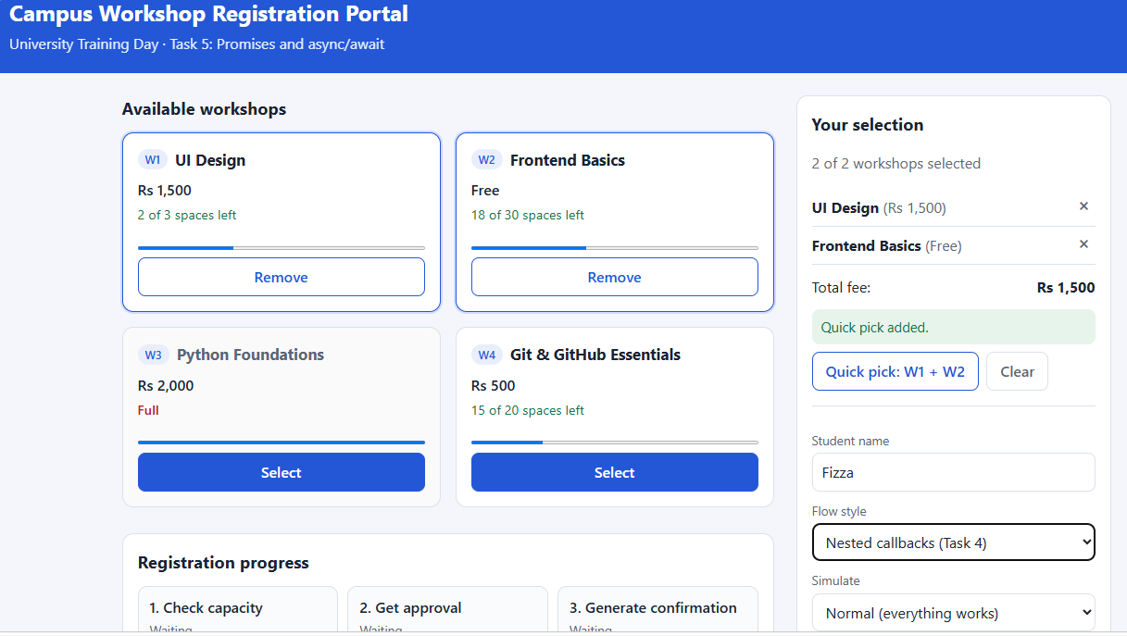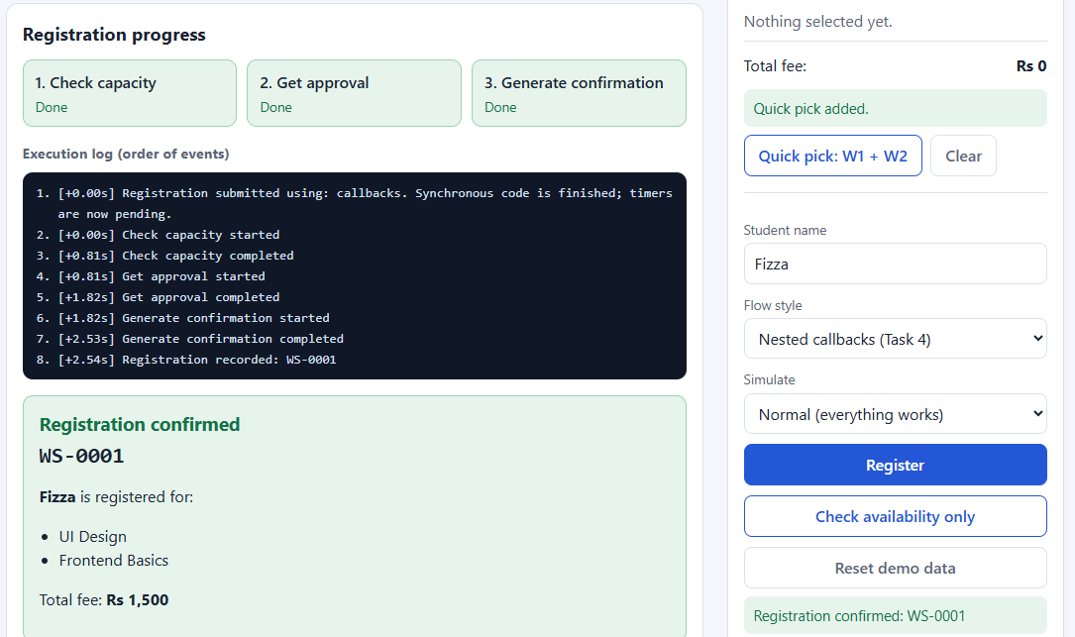
Task 6
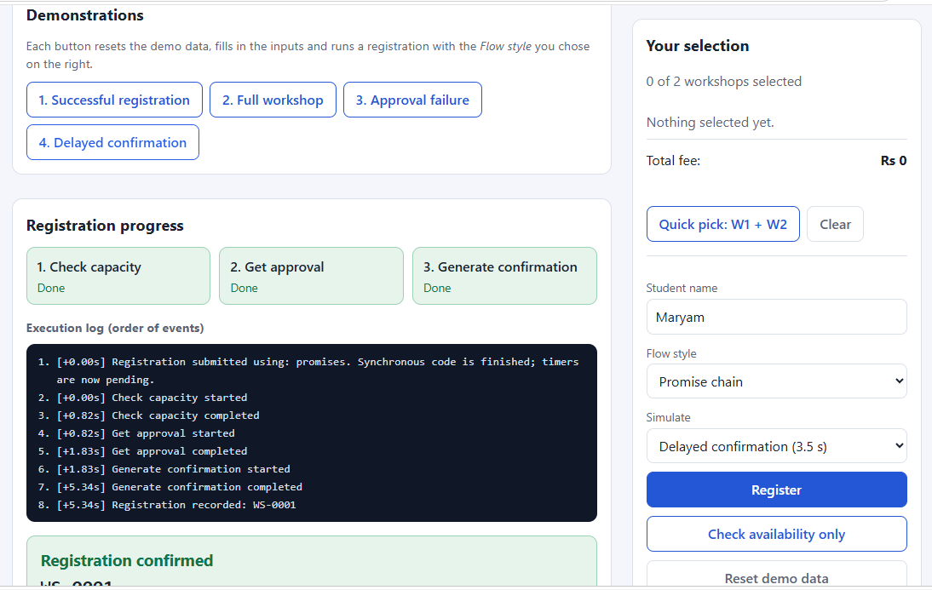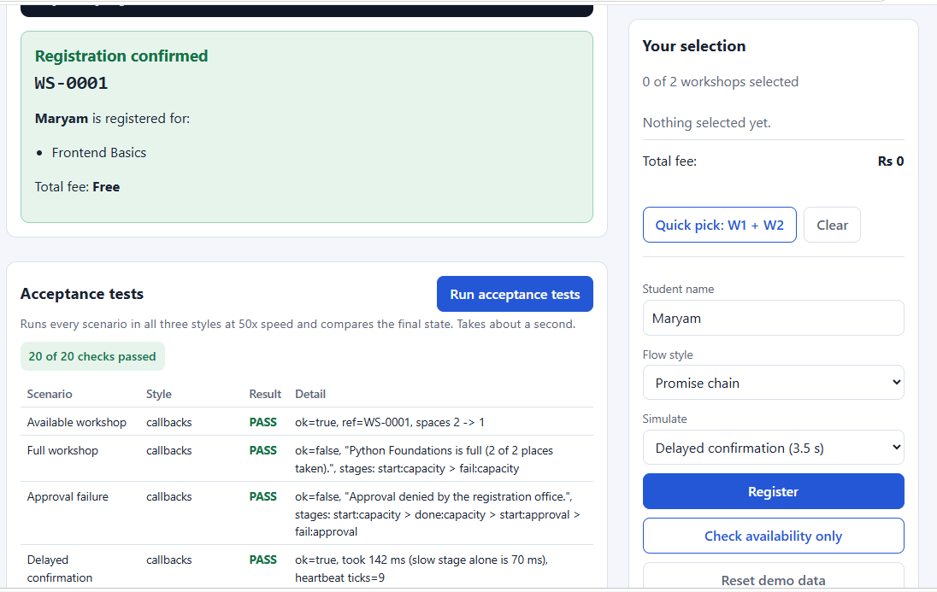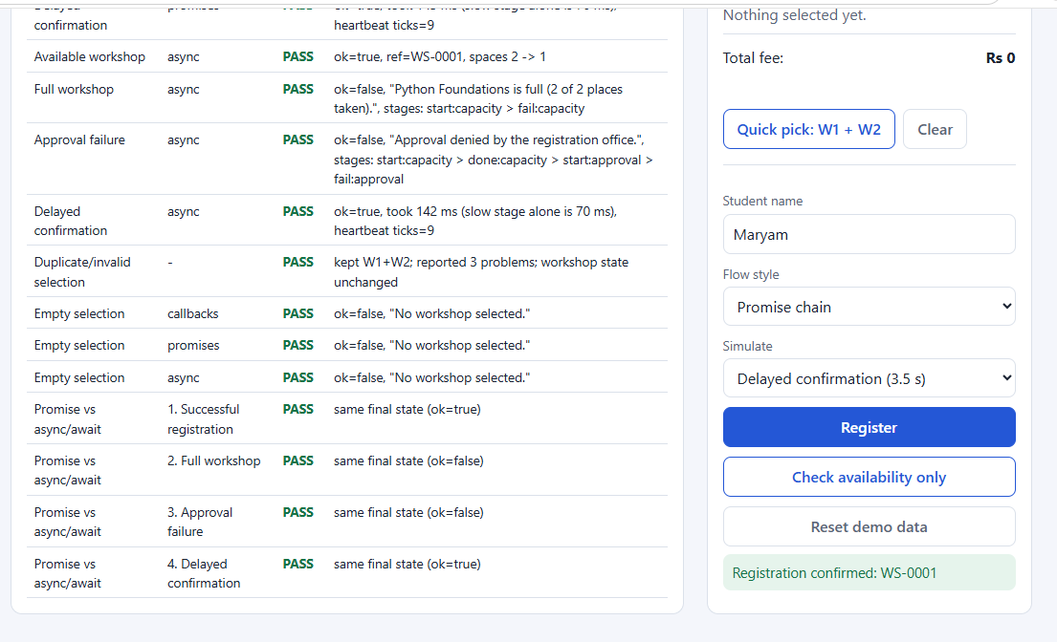
Concept | Where in the portal | What I learned
Module design (export / import) | workshops.js (data/state), selection.js (rules), callbacks.js / promises.js / asyncawait.js (services and flows), progress.js and ui.js (DOM), app.js (controller) | A module should have one job. Because services never touch the DOM, the same flows run on the page and inside the test suite without changes.
Destructuring | availableSpaces({ capacity, registered }), const { id, name } = workshop, reduce((sum, { fee }) => ...) | It makes the code say which fields a function really needs.
Template literals | Card HTML in ui.js, error messages such as ${workshop.name} is full (...) | Building HTML and messages is far more readable than string concatenation.
Spread | [...selection, id] for a new selection, addMany(selection, ...ids), { ids: [...selection] } for a run snapshot | Creating a new array instead of using push keeps state predictable, and the snapshot stops later clicks from changing a running registration.
Rest parameters | addMany(selection, ...ids) | One function can accept any number of workshop IDs. The same ... means "collect" in a parameter list and "expand" in a call.
Error-first callbacks | checkCapacity, obtainApproval, generateConfirmation | Always check error first and return after reporting it, otherwise the success path also runs.
Nested callbacks | registerWithCallbacks() | Dependent steps are guaranteed to run in order, but every extra stage adds indentation and another repeated if (error) block.
Promises | promisify(), tracked(), registerWithPromises() | Each .then() must return the next Promise; a rejection skips the remaining .then() calls and lands in one .catch().
async / await | registerWithAsyncAwait() with try / catch / finally | The flow reads top to bottom like synchronous code. await pauses only that function, which the heartbeat counter shows. finally is for logging, never for recording a booking.
Testing failures | tests.js, state snapshots before and after | Checking that failed runs leave the state exactly unchanged is more convincing than checking only the message.
Promises | promisify(), tracked(), registerWithPromises() | Each .then() must return the next Promise; a rejection skips the remaining .then() calls and lands in one .catch().
async / await | registerWithAsyncAwait() with try / catch / finally | The flow reads top to bottom like synchronous code. await pauses only that function, which the heartbeat counter shows. finally is for logging, never for recording a booking.
Testing failures | tests.js, state snapshots before and after | Checking that failed runs leave the state exactly unchanged is more convincing than checking only the message.

2. Comparing the Three Styles
Nested callbacks. A simple building block with no special syntax, but the pyramid of indentation grows with every stage, error handling is repeated at each level, and it is easy to forget a return. Sharing results with other code is awkward.
Promise chains. The chain is flat, errors travel to one .catch(), and Promises can be combined (Promise.all, Promise.race). The cost is discipline: forgetting to return the next Promise silently breaks the ordering, and variables from early steps are hard to reach in later .then() callbacks.
async / await. Easiest to read and debug: normal control flow, try / catch / finally, and early variables stay in scope. It is built on Promises, so I still need to understand them, and independent steps must still use Promise.all or they will run one after another by accident.

3. Which Style I Would Use in a Larger Application
I would use async/await for application logic, on top of Promise-returning services, and keep Promise utilities such as Promise.all for steps that can run in parallel. Raw callbacks I would keep only at the edges where a library requires them, and wrap them once with a helper like promisify(), exactly as this project does. In this lab, all three styles produced identical final states for identical inputs (20 of 20 tests passed), so the choice is about maintainability, not behaviour.

4. One Thing I Would Improve
Registrations exist only in browser memory, and two students registering at the same time could both pass the capacity check. A real system would need server-side capacity locking, persistent records and retry/compensation handling.

A. Demonstrations (real-time delays)
# | Style | Selected input | Expected | Actual
1 | Callbacks | W1, Normal | 3 stages Done, confirmation shown, UI Design spaces 2 -> 1 | All 3 stages Done in 2.50 s. Confirmation WS-0001. UI Design "1 of 3 spaces left".
2 | Promises | W3, Normal | Capacity fails; approval and confirmation never start; no record | Capacity Failed at +0.80 s ("Python Foundations is full (2 of 2 places taken)."). Approval and Confirmation Skipped. No confirmation card. Counts unchanged.
3 | Promises | W1, Approval failure | Capacity Done; approval fails; no confirmation | Capacity Done at +0.80 s, Approval Failed at +1.80 s ("Approval denied by the registration office."). Confirmation Skipped. UI Design still "2 of 3 spaces left".
4 | async/await | W2, Delayed confirmation | Page stays responsive; result appears only after the delay | Confirmation stage ran from +1.80 s to +5.30 s. While waiting, the heartbeat went 37 -> 41 in 1 s and no confirmation card was visible. After the delay: WS-0001, Frontend Basics 18 -> 17 spaces left.

B. Execution Timelines (order of events)
Success, callbacks:
1. [+0.00s] Registration submitted using: callbacks. Synchronous code
is finished; timers are now pending.
2. [+0.00s] Check capacity started
3. [+0.80s] Check capacity completed
4. [+0.80s] Get approval started
5. [+1.80s] Get approval completed
6. [+1.80s] Generate confirmation started
7. [+2.50s] Generate confirmation completed
8. [+2.50s] Registration recorded: WS-0001

Approval failure, promises:
1. [+0.00s] Registration submitted using: promises. ...
2. [+0.00s] Check capacity started
3. [+0.80s] Check capacity completed
4. [+0.80s] Get approval started
5. [+1.80s] Get approval FAILED: Approval denied by the registration office.
6. [+1.80s] Flow stopped. No registration was recorded.

C. Minimum Acceptance Tests
Scenario | Input | Expected | Actual
Available workshop | W1 (all 3 styles) | Progress completes, confirmation, spaces decrease | PASS x3. WS-0001, spaces 2 -> 1, exactly 1 record
Full workshop | W3 (all 3 styles) | Rejected at capacity; no approval or confirmation | PASS x3. Stages: start:capacity > fail:capacity; state unchanged
Approval failure | W1 + approval failure (all 3 styles) | Capacity OK, approval fails, no confirmation | PASS x3. Stages: start:capacity > done:capacity > start:approval > fail:approval; state unchanged
Delayed confirmation | W2 + slow (all 3 styles) | Responsive; completes only after delay | PASS x3. Elapsed >= slow stage delay; heartbeat ticks 22 (never frozen)
Duplicate / invalid selection | W1, W1, W9, W2, W4 | Prevented or reported; consistent state | PASS. Kept W1+W2; reported 3 problems (duplicate, invalid ID, limit); workshop data unchanged
Empty selection | No workshops (all 3 styles) | Rejected; nothing recorded | PASS x3. "No workshop selected."; state unchanged
Promise vs async/await | Each of the 4 demo inputs | Same final state | PASS x4. Same ok, same error text, same snapshot (callbacks also identical)

Total: 20 of 20 checks passed.
Sanity check of the tests themselves: when the approval-failure rule was deliberately broken in a temporary copy, the suite reported 3 FAIL results (one per style), so the tests do detect real faults.

